Why go home over Christmas when there’s so much to do in Bristol?!
Some information about Xmas events – produced by the SoE Climate Action Group

Tuesday 2nd December 13.00-14.00
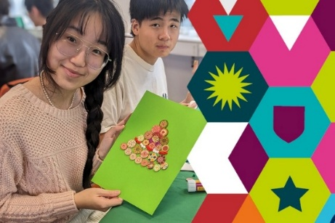
“Culture Club: make Christmas Cards for your friends and family” at the Global Lounge. Simply drop in during the event time, no booking needed.
Join us for a festive card making session in the Global Lounge! Afterwards, take your creations home to send to friends and family across the globe. Create and connect with students from all around the world! We’ll provide hot drinks to fuel your crafting, alongside a delicious, seasonal teas and beverages. We will also provide you with all the materials you need, completely for free! Whether you want to fill your card with glitter or keep it simple, there will be lots of decorations to choose from. Come along to enjoy a warm, festive atmosphere as you chat and create!
Tuesday 2nd December 17.00-19.00 “Winter wonder evening fest” at the Global Lounge (Tickets will be released 8 days before the event date - Tickets on the Global Lounge site: global-lounge.bristol.ac.uk)

You are cordially invited to the Global Lounge for a Christmas-themed hot meal to kick off our 2025 Festive Programme! Get dressed up (if you'd like to) and come along to the Global Lounge, which will be specially decorated for the season. Enjoy a delicious, free, sit-down meal with all the trimmings as you mingle with students and staff from around the globe.
Tuesday December 9th University of Bristol Christmas Carol Service – in the Wills Memorial Building 12:30 - 15:00. Tickets on the Global Lounge site: global-lounge.bristol.ac.uk
Joy to the World! During the festive season, many people celebrate Christmas by attending a traditional carol service. Join the Multi-faith Chaplaincy, the Department of Music, and the Global Lounge for a beautiful Carol Service in the Great Hall of Wills Memorial. All students and staff are welcome! The University of Bristol’s Carol Service is one of the highlights of the year.
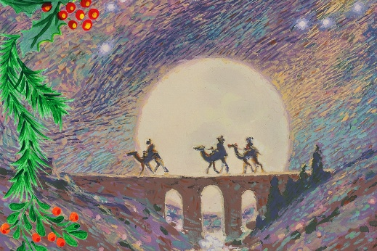
Wednesday 17th December SOE Student Christmas Party Rm 4.10 in School of Education at 16.00. Food, drinks and music! Just come along…..

Thursday 18th December Festive Afternoon Tea, with all the trimmings
By Global Lounge 14.00-16.00 Tickets on the Global Lounge site: www.global-lounge.bristol.ac.uk
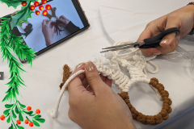
Enjoy a delicious afternoon tea in the Global Lounge while meeting other students from around the globe, all with a fun festive flair!
Join the Global Lounge team and student Ambassadors for freshly baked scones with jam and cream, cakes, sandwiches, tea, coffee, and more.
This is also a chance to get creative and weave your own macrame Christmas tree decorations. We'll provide everything you need to make your own macrame stars, wreaths, trees, reindeer and other festive shapes.
Friday 19th December Karaoke Rm 4.10 in School of Education at 16.30. End of term sing session. All SoE students welcome! Free snacks and non-alcoholic drinks.
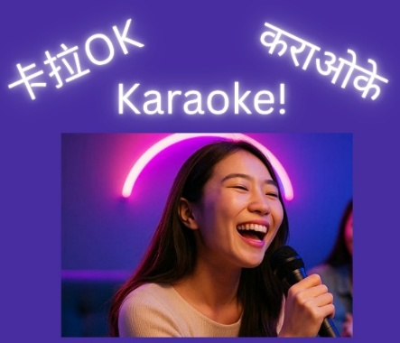
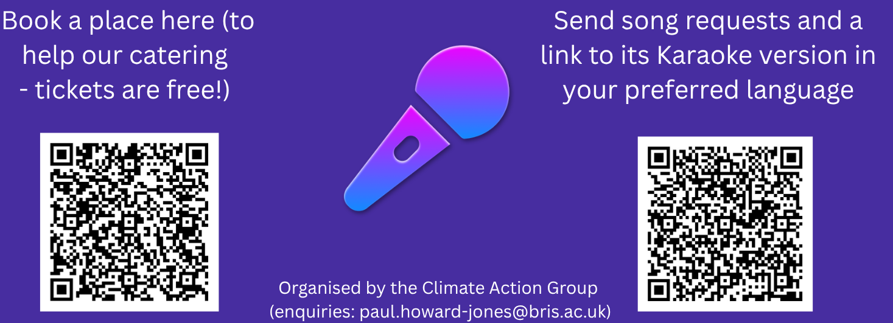
Monday 22nd December Festive Breakfast at the Global Lounge 10.00-12.00 (Tickets will be released 8 days before the event date - Tickets on the Global Lounge site: global-lounge.bristol.ac.uk)
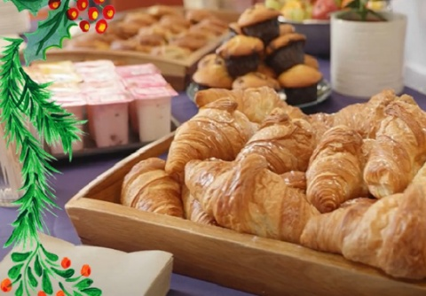
Enjoy a free delicious breakfast, while you learn about Christmas and Hannukah traditions and their importance to those who celebrate them. You'll hear Sam, the University’s Christian Chaplain, talk through the Nativity story and the many ways that Christmas is celebrated. We will also touch upon the Jewish celebration of Hannukah on its eighth and final day. Afterwards you can try your hand at candle holder-painting, an activity which integrates the symbolism of light which is present in both traditions.
Join us for: A delicious free breakfast including pastries, muffins, yoghurt, fruit and other treats; Festive juices and hot drinks; An interesting and informative presentation from a University Chaplain; A fun, creative craft for you to take home.
Tuesday 23rd December Connect and create, with wreath-making and festive treats at the Global Lounge 10.00-12.00 (Tickets will be released 8 days before the event date - Tickets on the Global Lounge site: global-lounge.bristol.ac.uk)
Get into the Christmas spirit with the Global Lounge. Create your very own festive wreath to decorate your home. Plus, enjoy a festive hot chocolate bar with marshmallows and whipped cream, Christmas cake and gingerbread, all for free! The Global Lounge will give you everything you need to create your very own wreath. From holly leaves and twigs, to ribbons and lots of inspiration. No creative talent is needed and everyone is welcome to have a go! You can also use the time to soak up the atmosphere of the Lounge, relax and chat to others. This is the place for new and old friendships to bloom.

Even when the university is closed, there’s more to do!
Visit Tyntesfield – a beautiful old English house with extensive garden and parkland – just hop on the X6 bus from Bristol. The grounds are beautiful, and they adorn the house with traditional Christmas decorations – it's extremely festive!

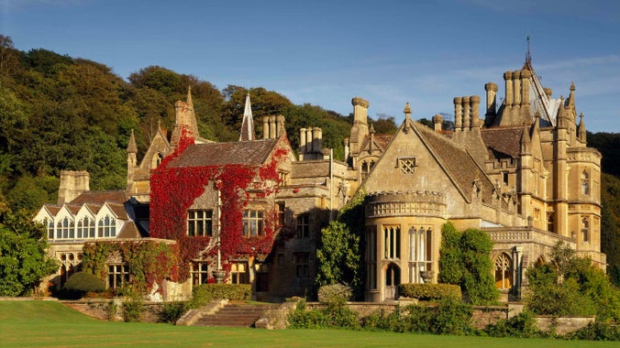

Visit Bristol Zoo Project (open all December except Christmas day 25th) – lots of animals to see including giraffes, zebras and meerkats. Plus …..experience England as it was thousands of years ago: A winding treetop walkway guides you through an ancient woodland where brown bears, wolverines, lynxes and wolves roam (and enjoy a hot chocolate in the café afterwards).
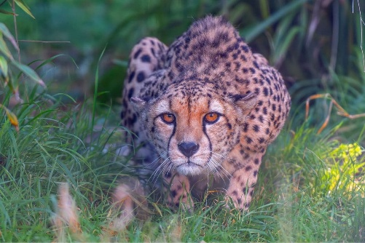
Book your zoo ticket and take a Bus 1,2 or 2a from Bristol city centre to Catbrain Lane Cribbs Causeway and walk 10 minutes to the Zoo entrance

And there’s more…..Bristol is one of the cultural capitals of the world! Have a look at these free guides:
www.headfirstbristol.co.uk and www.bristol247.com/guides/
which list live music, club nights, art exhibitions, stand up and theatrical performances every day of the year. Many events are completely free, others are ticketed and you can buy tickets directly through headfirst (it’s a not-for-profit and doesn’t charge any commission). For example:
Friday 19 December 19.30 DOVETAIL ORCHESTRA
Art over adversity – spirited transnational music in exile. A celebration of the universality of music, with an inspirational and adventurous ensemble of refugees and asylum-seekers. £14 in advance | £16 on the door | £5 conc. BOOK NOW: hdfst.uk/E132965

You might also want to see a show:
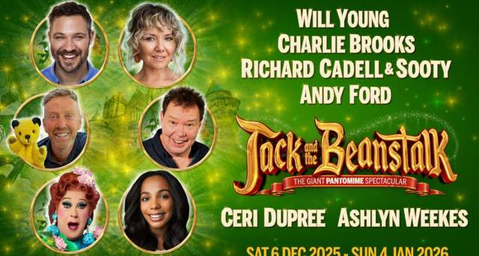
Go and watch a pantomime. A “panto” is a typically British form of theatre where the audience are invited to participate and sing along, it’s great fun! Get a ticket to Jack and the Beanstalk at Bristol Hippodrome or Sleeping Beauty at The Redgrave Theatre or Treasure Island at Bristol Old Vic. The pantomime tradition encourages only collective participation (everyone together – and no-one will notice if you don’t participate – so nothing embarassing!)
Other festive shows include Rapunzel: A Hairy Tale at Tobacco Factory Theatres and Moolin Scrouge at The Wardrobe Theatre. Bristol's pop-up Christmas venue, The Spiegeltent, also offers a range of festive entertainment throughout December.

Have a great Xmas!

Xmas greetings from the Climate Action Group
(Contact: paul.howard-jones@bris.ac.uk)

